Non-restrictive (Nonessential) Appositive

🔹 What is Non-restrictive (Nonessential) Appositive?
# Source: AI Source: Provided by: [Data Path: Persons Table -> ID Column: 1, Name_En Column: Motasem Essam] -> From: [Chatgpt (GPT‑5 Mini)] on [8/7/2025]
A non-restrictive (nonessential) appositive is a noun or noun phrase that adds extra information about a noun that is already clear or specific.
It can be removed without changing the core meaning of the sentence. It is set off by commas.

🔸 Key Features:
# Source: AI Source: Provided by: [Data Path: Persons Table -> ID Column: 1, Name_En Column: Motasem Essam] -> From: [Chatgpt (GPT‑5 Mini)] on [8/7/2025]
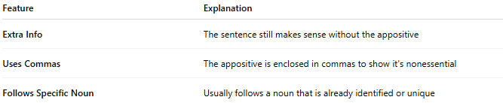
Feature | Explanation
Extra Info | The sentence still makes sense without the appositive
Uses Commas | The appositive is enclosed in commas to show it's nonessential
Follows Specific Noun | Usually follows a noun that is already identified or unique

🔸 Examples:
# Source: AI Source: Provided by: [Data Path: Persons Table -> ID Column: 1, Name_En Column: Motasem Essam] -> From: [Chatgpt (GPT‑5 Mini)] on [8/7/2025]
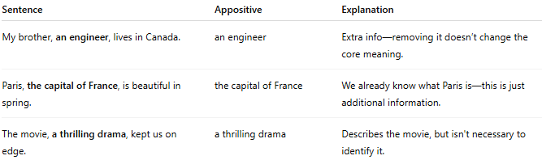
Sentence | Appositive | Explanation
My brother, an engineer, lives in Canada. | an engineer | Extra info—removing it doesn’t change the core meaning.
Paris, the capital of France, is beautiful in spring. | the capital of France | We already know what Paris is—this is just additional information.
The movie, a thrilling drama, kept us on edge. | a thrilling drama | Describes the movie, but isn't necessary to identify it.

